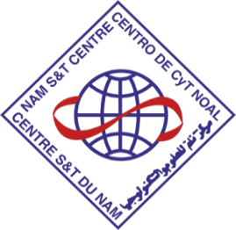 | 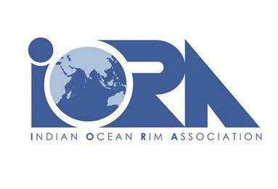

Extension of the IORA-NAM S&T Centre MOU

New Delhi, India, 29 September 2022:

H.E. Dr. Salman Al Farisi, the Indian Ocean Rim Association (IORA) Secretary-General and Dr. Amitava Bandopadhyay, Director General, NAM S&T Centre, have agreed to extend the Memorandum of Understanding (MOU) for cooperation between the two sides until 2025.

The MOU was initially signed on 7 November 2019 on the margins of the IORA Council of Ministers’ Meeting in Abu Dhabi, United Arab Emirates. The MOU established the basis for an organizational arrangement to encourage engagement in the broad fields of Academic, Science & Technology for capacity building and joint activities to achieve the Sustainable Development Goals (SDGs) through the application of Science, Technology & Innovation (STI) in the IORA and NAM S&T Centre’s Member States for mutual benefit, and on the basis of equality and reciprocity.

Although cooperation under the MOU was hampered owing to the COVID-19 global pandemic, both sides jointly conducted a very successful International (Virtual) Workshop on the 'Role of Science, Technology and Innovation (STI) in Achieving Sustainable Development Goals - 2030', on 24-25 May 2022.

The MOU was set to expire on 6 November 2022, and it was agreed to extend the MOU by a further three
(3) years until 2025.

Secretary General Dr. Al Farisi welcomed the extension as the confirmation of NAM S&T Centre’s ongoing commitment to cooperate with IORA in the realm of STI. Dr. Amitava Bandopadhyay, Director General, expressed his happiness on the renewal of MoU for further engagements in the application of STI for capacity building and dissemination of knowledge to achieve SDGs in IORA and NAM S&T Centre's Member States through collaborative initiatives/programs and joint publications.

Follow the conversation @IORAofficial #IORAOfficial #IORANews #IORAMedia

