Official Press Release Twelfth Bi-annual Meeting of the IORA Committee of Senior Officials (CSO) 28-29 July 2022
IORA News
29 July 2022

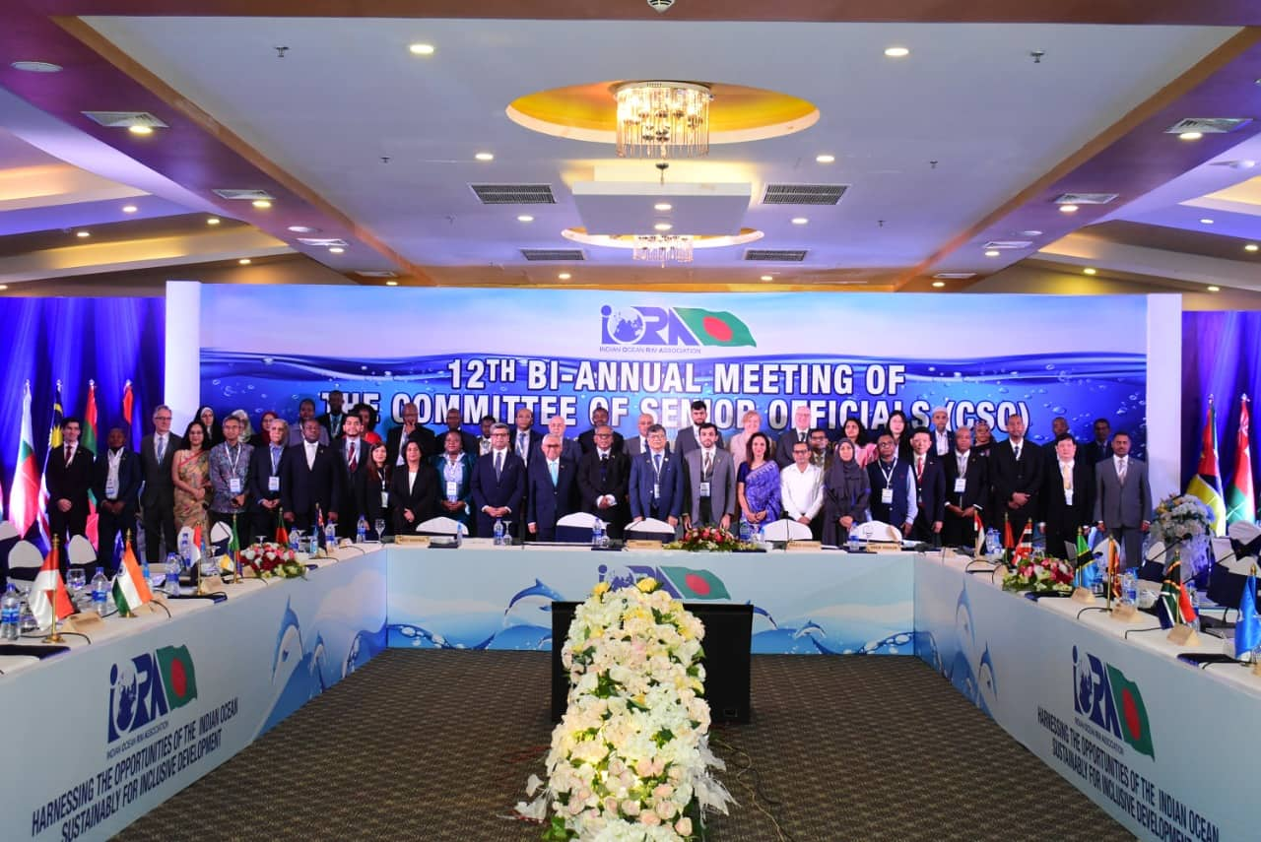

Bangladesh, the current Chair of the Indian Ocean Rim Association (IORA), convened 12th Bi-Annual Meeting of the Committee of Senior Officials (CSO) of the Indian Ocean Rim Association (IORA) in Cox’s Bazar, Bangladesh on 28-29 July 2022. Forty-six (46) delegates from twenty-one (21) Member States and IORA Secretariat attended the Meeting. This meeting discussed on the progress made to date under the six priority areas and two cross-cutting issues of the Association and financial issues. Member States also discussed preparations for upcoming events and meetings of IORA’s institutional mechanisms as well as IORA’s engagement with its international partners and special programmes.
Foreign Secretary (Senior Secretary) of Bangladesh Ambassador Masud Bin Momen has delivered the opening remarks and conducted the first session of the Meeting of the CSO of IORA on behalf of the host country on the first. IORA Secretary General H.E. Dr. Salman Al Farisi, Vice-Chair Ms. Manorie Malikaratchy, Acting Director General, Ministry of Foreign Affairs of Sri Lanka., IORA past chair H.E. Mr. Abdul Nasser AlShaali, Assistant minister for Economic and Trade Affairs of UAE, Rear Admiral (Retd.) Md. Khurshed Alam, Secretary, Maritime Affairs Unit of the Ministry of Foreign Affairs of Bangladesh delivered their remarks.
In his speech, Ambassador Masud appreciated the Secretary General and his colleagues in the Secretariat for their admirable initiatives in preparing the ground for making the present meeting as fruitful as possible and to resolve all outstanding internal staffing, pay-scale and financial matters. He also thanked all the Member States for their efforts in the recent past and for strengthening the IORA platform to address all important maritime issues even amidst the trying days of pandemic.
Senior Secretary Masud urged the Member States of IORA to share ideas and exchange visions and to put their best and collective efforts to maintain the strong momentum generated in the recent years to take this platform to a greater height. He also reiterated the commitment of the Government of the People’s Republic of Bangladesh to continue working closely with all Member States of IORA for successful materialization of the objectives of our Association.

Noteworthy, Bangladesh assumed the Chairship of IORA in November 2021 for a period of two years (2021-2023) with the theme - “Harnessing the Opportunities of the Indian Ocean Sustainably for inclusive development” and this was its second CSO meeting as Chair.

Follow the conversation and stay up to date about the IORA’s work at @IORAofficial.
Say connected with us by visiting:
• Website: https://www.iora.int/en
• LinkedIn: https://www.linkedin.com/company/indian-ocean-rim-association/
• Instagram: https://www.instagram.com/ioraofficial/
• Twitter: https://twitter.com/IORAofficial
• Facebook: https://www.facebook.com/IORAofficial

