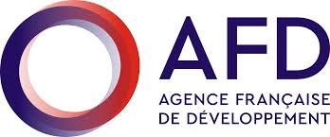
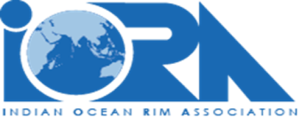
Web-Text
AFD – IORA Webinar on “Promoting the manual of blue carbon standard methods to be used for standardised baseline data sets”

Venue: Webinar on “Promoting the manual of blue carbon standard methods to be used for standardised baseline data sets”

As part of the French Development Agency (AFD) funded technical assistance for the implementation of the IORA Action Plan on Fisheries, Aquaculture and the Marine Environment, the AFD provides support to the achievement of the Blue Economy Work plan. The overall objective of the technical assistance (TA) is to support IORA and its Member States in the coordination and implementation of the Work Plan of the Working Group on the Blue Economy, with a strong focus on fisheries, aquaculture and protection of the marine environment.
One of the specific objectives of this Work Plan is “Standardising Blue Carbon assessment methods in the Indian Ocean”. In the context of this objective, the activity “Develop a manual of blue Carbon standard methods to be used for standardised baseline data sets” was planned but since a manual had already developed by the Blue Carbon Initiative (BCI) the IORA decided to use the BCI manual.
IORA recognises that healthy blue carbon ecosystems provide habitat for marine species, support fish stocks and food security, sustain coastal communities and livelihoods, filter water flowing into our oceans and reef systems, and protect coastlines from erosion and storm surges. As such, the IORA Secretariat will deliver, in collaboration with the IORA Blue Carbon Hub, a Webinar to promote and introduce to as many stakeholders in the IORA Member States the use of the Blue Carbon manual developed by the Blue Carbon Initiative, its application, and benefits and to understand any challenges faced by the Member States.

Participation: All
Title: Webinar on “Promoting the manual of blue carbon standard methods to be used for standardised baseline data sets”
Venue: Online
Date: Monday 23 January 2023 at 0700 Hrs (GMT)

Registration: All
Link for Registration: https://forms.gle/k2p8E1KBmMagyf1r6
The online workshop will be moderated by Mr. Rondolph Payet, the Main Residence Expert for the AFD Technical Assistance to IORA. The speakers will include experts from IORA Blue Carbon Hub, Blue Carbon Initiative, AFD, IUCN and IORA Member States.

