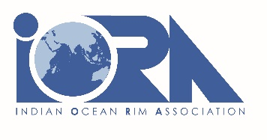

PRESS RELEASE

IORA AND IOC OF UNESCO SIGN MoU TO STRENGHTEN PARTNERSHIP ON OCEAN SCIENCES

Mauritius, 14 March 2023 –, H.E. Dr. Salman Al Farisi, the Secretary-General of Indian Ocean Rim Association (IORA) and Dr. Vladimir Ryabinin, the Executive Secretary of the Intergovernmental Oceanographic Commission of the United Nations Educational, Scientific and Cultural Organization (IOC of UNESCO), signed a Memorandum of Understanding (MoU) today.

The MoU provides a framework for future cooperation between IORA and IOC of UNESCO to promote capacity development for their Member States in ocean sciences and its applications to the sustainable ocean economy. Within the framework of MoU, the IOC of UNESCO and IORA will be able to establish a joint capacity building programmes on many areas of cooperation.

“I wish to reiterate our strong commitment to work closely with IOC of UNESCO to meet our shared goals under our areas of common interest, and also in line with the UN 2030 Agenda for Sustainable Development, including the Sustainable Development Goals” said Secretary General Salman Al Farisi.

“I am confident that our joint collaboration will develop the capacities and capabilities of the countries in the region in ocean science and its applications to sustainable blue economy” he added.

The Executive Secretary of IOC of UNESCO said “Our paradigm is to generate new level of science, which is the basis for sustainable ocean planet and sustainable ocean management, taking into account the economy, climate change and reducing pollution. With that, regional economies will have solid foundation for growth. This is exactly the goal of IORA, and we are ready to work with the Association toward achieving that goal”.

The IOC of UNESCO is a functional body within UNESCO that promote international cooperation and coordinates programmes in research, service and capacity-development in order to learn more about the nature and resources of the ocean and coastal areas. The partnership between IORA and IOC of UNESCO will provide opportunities to assist IORA Member States in developing their capacities, technical knowhow, and human resources in ocean sciences.

